**Spring Boot Demo with Swagger, RabbitMQ, Redis and Keyclock authentication with MySql Connection.**

1. Download the below software

RabbitMQ server

Redis server

Keyclock server

MySql server

1. Download the below development tools software

STS/Eclipse

MySql workbench

1. Do set RabbitMQ server

For Multiple Module Maven project:

Please follow below steps to create the multi-modules maven project.

1. Create New maven project in Eclipse menu. Select Archetype asmaven-archetype-quickstart. In next window input Group Id, Artifact Id etc. For example, Group Id – jeejava, Artifact Id – spring-microservices, Version – by default auto populated. Now open thepom.xmlfile and change the packaging type as *pom*. If you find any problem on the project then simply doMaven -> Update Project.
2. Now do right click on the spring-microservices project and clickNew -> Other. In the Wizard window selectMaven -> Maven Module. In the next window input Module Name asuser-service. Make sure that Parent Project selected asspring-microservices. On next window select Archetype asmaven-archetype-quickstart. In next window accept all defaults and click Finish. Now you will see in the parent project’s (spring-microservices) pom has been updated with<modules/>tag. Now open the user-service project’s pom.xml file and remove<groupid/>and<version/>tags. Because these two values will be inherited from parent project.
3. Now create another moduleemail-servicein the similar way as you have createduser-service. Remove the<groupid/>and<version/>tags from the pom.xml file. Now again you will see the parent’s pom file has been updated to include theemail-servicemodule under<modules/>tag.

The project structure will look like similar to the below image

[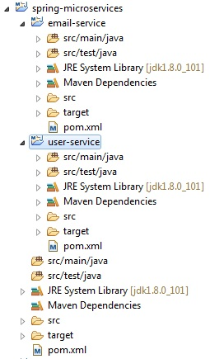](https://www.jeejava.com/wp-content/uploads/2017/05/multi-module-project-structure.jpg)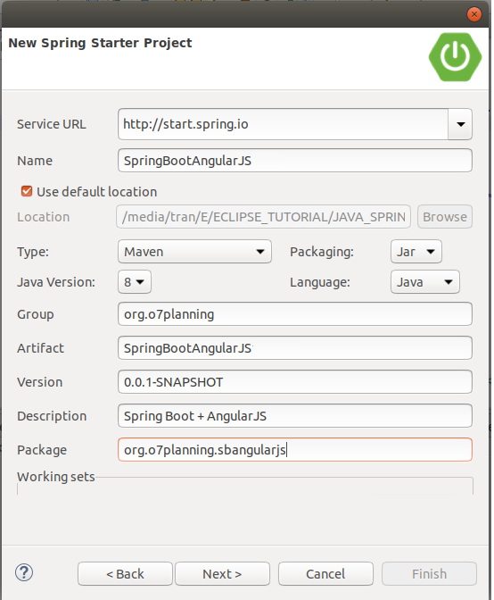

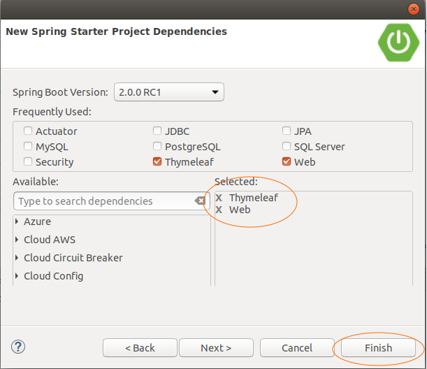

To install Angular 4, we require the following −

* Nodejs
* Npm
* Angular CLI
* IDE for writing your code

<https://nodejs.org/en/download/>

<https://cli.angular.io/>

[https://code.visualstudio.com](https://code.visualstudio.com/)

Commands of Angular:

node –v // To check version

npm -v // To check version

npm install -g @angular/cli //command to install angular 4

ng new Angular 4-app // To create new project

ng serve //To compile angular app

ng g component new-cmp // To create new Component

ng generate component componentName --module=app.module // To create new Component

npm install --save-dev @angular-devkit/build-angular // To fix the error for devopmentool kit not found

ng update @angular/cli

npm i --save-dev @angular/cli @angular-devkit/build-angular @angular/compiler @angular/compiler-cli // To fix issue related to angular migration